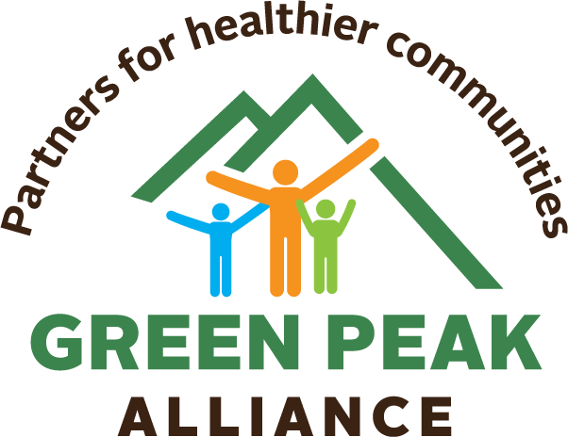

Research shows that children with more frequent and high-quality contact with non-parental adults have fewer behavior problems. As leaders who work with youth, you’re a great influence on the lives of young people. We’ve created points to keep in mind when talking to youth about vaping.
Vaping: Quick Facts

- An outbreak of e-cigarette or vaping-use associated lung injury (EVALI) began in late summer 2019 and is still ongoing.
- EVALI is a serious condition whose symptoms include fever and chills, cough, vomiting, diarrhea and headache. It often requires hospitalization and can lead to death.
- Vapor contains ultrafine particles, flavorings linked to lung disease, and heavy metals.
- While vaping is marketed as “safer” than cigarettes, that’s not the same as safe, and the science is still inconclusive.
- Vaping increases complications of COVID-19. Protect your lungs!

Did you know?
- E-cigarettes/vapes and other tobacco products are illegal for people under 21.
- Companies target kids to profit on getting them addicted at an early age. Don’t fall for advertisers’ tricks!
- Nicotine in vapes is not just harmful to lungs: it’s harmful to your developing brain.
- Cigarettes and vaping deliver addictive nicotine, which can change your brain and threaten your mental health.
- If you start vaping under the age of 21, you’re more likely to become addicted, have more difficulty quitting, and may be at higher risk for addiction to other substances.
- Pediatricians and doctors are very concerned about youth who vape and want to help. They may have ways to help kids quit vaping for free.
- Kids can receive immediate, free help from The Truth Initiative by texting DITCHJUUL to 88709
Learn more:
www.greenpeakalliance.org
info@greenpeakalliance.org

Child and Adolescent Social Work Journal https://link.springer.com/article/10.1007/s10560-005-2546-4
Centers for Disease Control (2020). https://www.cdc.gov/tobacco/basic_information/e-cigarettes/severe-lung-disease.html
Environmental Health Perspectives, 126(2). https://ehp.niehs.nih.gov/doi/full/10.1289/EHP2175
Journal of Adolescent Health, 67(4), 519-523.
Cold Spring Harb Perspect Med. 2012;2(12):a012120. Published 2012 Dec 1. doi:10.1101/cshperspect.a012120
The Truth Initiative: https://truthinitiative.org/thisisquitting

