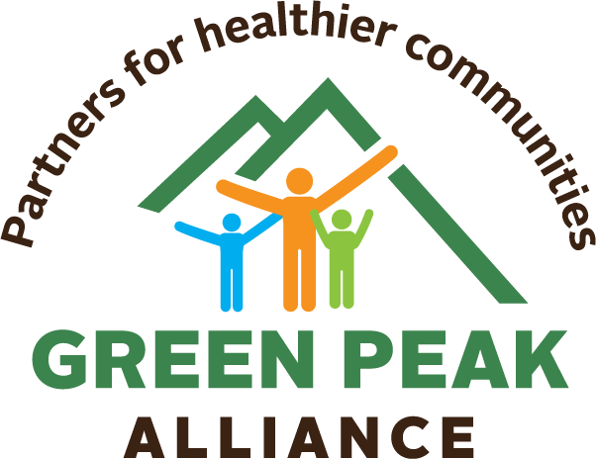

Research shows that children with more frequent and high-quality contact with non-parental adults have fewer behavior problems. As leaders who work with youth, you’re a great influence on the lives of young people. We’ve created points to keep in mind when talking to youth about marijuana.

Cannabis: Quick Facts

- Cannabis is illegal for people under 21.
- Cannabis is stronger than it has been since the 90s— increasing its adverse effects
  - cannabis with more than 15% THC content carries a 3x-5x increased risk of developing psychosis depending on frequency of use. Knowing Marijuana potency can be lifesaving.
- Cannabis is an addictive substance. If you use marijuana when you’re young, you can develop cannabis use disorder and increase your chances of becoming addicted to any substance.

Did you know?
- Most teens in Vermont do NOT use cannabis. In a state-wide survey, 73 percent of high school students reported that they did not use marijuana.
- Cannabis affects brain development and can lead to memory loss and difficulty concentrating.
- Cannabis has three times the level of THC (the compound that gets you high) than it did in the 90s.
- Increased THC raises the risk of developing schizophrenia, a serious mental illness.
- Cannabis worsens anxiety. Find other ways to reduce stress, such as exercise and meditation.
- Sports are “recreational”: cannabis is not. People over 21 can “adult-use” cannabis, but your brain is still developing.
- Statistics show that using cannabis at a younger age can lead to lower earnings as an adult, and makes a person less likely to earn an advanced degree. Don’t let cannabis get in the way of your goals.

Learn more:
www.greenpeakalliance.org

Child and Adolescent Social Work Journal https://link.springer.com/article/10.1007/s10560-005-2546-4, Journal of Extension https://www.joe.org/joe/2010october/pdf/JOE_v48_5tt4.pdf
For the purpose of this document, we are referring to “cannabis” with THC that is smoked, ingested, or inhaled to get high.
Missouri medicine, 115(6), 482–486.
Vermont Youth Risk Behavior Survey:Marijuana use, past 30 days, https://www.healthvermont.gov/sites/default/files/documents/pdf/CHS_YRBS_statewide_report.pdf
National Institute on Drug Abuse:https://www.drugabuse.gov/publications/research-reports/marijuana/how-does-marijuana-use-affect-school-work-social-life
Subst Abuse. 2013;34(3):298-305. doi:10.1080/08897077.2013.775092

