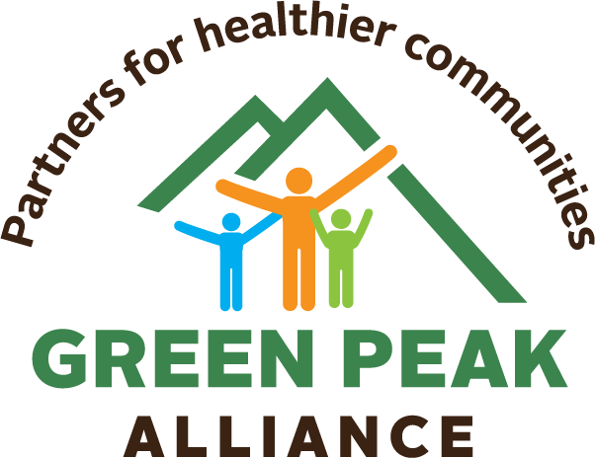
]

Cannabis: Quick Facts

- Cannabis is illegal for people under 21
- Cannabis is stronger than it has been since the 90s— increasing its adverse effects
  - Marijuana with more than 15% THC content carries a 3x-5x increased risk of developing psychosis depending on frequency of use. Knowing Marijuana potency can be life saving.
- Cannabis is an addictive substance. People who use it can go on to develop cannabis use disorder and are more likely to become addicted to other substances.
- Cannabis can increase the risk of mental health conditions, such as depression and anxiety.
- COVID-19 injures the lungs. Cannabis increases that damage.

Parents, did you know?

- Cannabis will affect your child’s developing brain. Be careful when pregnant or breastfeeding.
- Cannabis smoke has many of the same cancer-causing chemicals as cigarette smoke. Keep kids’ lungs healthy by keeping kids away from marijuana smoke and vapor.
- Kids can’t tell the difference between cannabis brownies and regular brownies. Secure edibles and all cannabis products where kids can’t access them.
- You can teach prevention early on: Talk with your kids about staying healthy. Introduce fruits and vegetables as a foundation for a healthy brain and body
- If you see an opportunity to talk about cannabis, engage your kids in conversation. Listen to what they have to say about what they are hearing.
  - Stick with the facts about cannabis.
  - Let them know this product isn’t safe for kids who are still growing.

Learn more:
www.greenpeakalliance.org
info@greenpeakalliance.org

For the purpose of this document, we are referring to “cannabis” with THC that is smoked, ingested, or inhaled to get high.
Stuyt E. (2018). The Problem with the Current High Potency THC Marijuana from the Perspective of an Addiction Psychiatrist. Missouri medicine, 115(6), 482–486.

