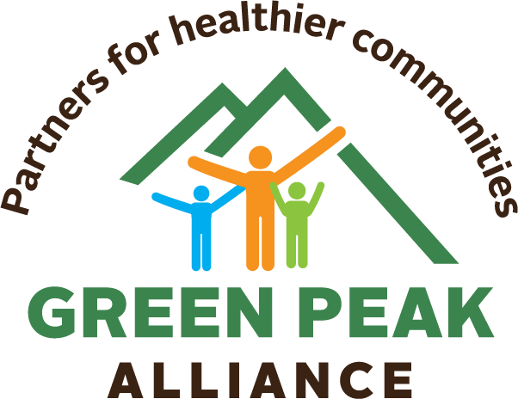
CBD: Quick Facts

- Cannabidiol (CBD) is a naturally occurring compound of industrial hemp/cannabis
- Marijuana contains both CBD and THC.
- THC causes the “high,” while CBD does not.
- Any use of CBD as a vitamin supplement or homeopathic treatment is risky because it has not been studied for safety and/or effectiveness.

Parents, did you know?
- Many CBD products are available in retail market settings, such as Farmers’ Markets and Food Co-ops.
- There are no regulations in place to ensure that CBD products sold in retail settings have no or low amounts of THC in them, leading to accidental ingestion and a THC “high”.
- Vermont law does not currently restrict the sale of CBD products to minors.
- However, because it has not been subjected to scientific study, there is no determination of safety for use by children.
- CBD can be found in products appealing to children, such as candy and honey.
- Check the labels of foods you and your children buy to determine if they contain CBD.
- If you have younger children, talk to their friends’ parents and let them know if your child should not consume CBD.
- If you have older children, talk to them about the dangers of consuming a product that hasn’t been tested for safety.
- CBD is approved for use as one type of medication in controlling seizures in children with a certain type of epilepsy, showing that it has an effect on brain activity.
- No studies have been conducted to determine whether CBD has therapeutic properties or is safe for children to ingest.
- The most common side effects of CBD are nausea, vomiting, diarrhea, and bloating.
- 10 percent of patients in a CBD seizure study showed liver function changes and 3 percent discontinued the study due to possible liver damage.
- Let your medical provider know if you and/or your child use CBD. Drug interactions between CBD and other common medications have been found and could result in toxicity or serious side effects.

Learn more:
www.greenpeakalliance.org
info@greenpeakalliance.org

